


West Coast Collaborative
Specialist Mathematics Units 3 & 4
Test 2 2018
Functions & Sketching Graphs
Task weighting: 7%
Calculator Free Section

Name: __________________________ Score: _____ / 22
Time Allowed: 22 minutes, under test conditions
Materials Allowed: SCSA formula booklet
Materials required: Standard items: Pens (blue/black preferred), pencil, sharpener, correction fluid/tape,
eraser, ruler, highlighters.
Instructions: Where a question or part of a question is worth more than 2 marks sufficient working to justify your solution is required. Simplify answers where possible.

Question 1. (3 marks)

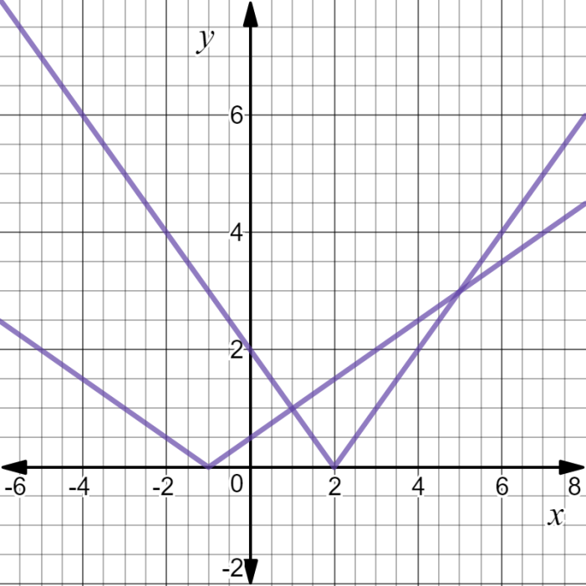
Use the diagram opposite to assist you to solve:

- $0.5\left|x+1\right|≤2$

- $2-x=0.5\left|x+1\right|$

- $\left|2-x\right|>0.5\left|x+1\right|$

Question 2. (4 marks)

Consider the nature of the graph of $y=$ $\frac{x^{2}+x-6}{x^{3}+4x^{2}+3x}$ . Describe the effect on the y values of the
graph as
- x tends to $-∞$

- x tends to ${-3}^{+}$

- x tends to $-1^{-}$

- x tends to $-2^{-}$
Question 3. (3 marks)

The graph of $y=\left|x-3\right|-2$ is shown below. Find $b$and $c such that the solution to the$equation

$\left|x-3\right|-2=-\left|x+b\right|+c$ is $x=-2, 9$.

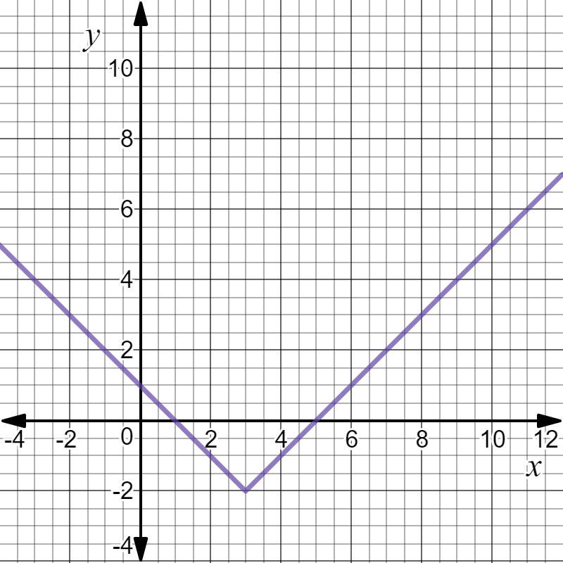

Question 4. (4 marks)

If $f\left(x\right)=3-$ $\frac{2}{x}$ determine

- $f^{-1}(4)$ (2)

- The value(s) of x such that $f^{-1}(x)=f(x)$. (2)

Question 5. (4 marks)

If $f\left(x\right)=x^{2}+2$and $g\left(x\right)=$ $\frac{1}{x+3}$ find the natural domain and corresponding range for

- fog(x) (2)

- gof(x) (2)

Question 6. (4 marks)

Find an expression for the inverse function of $p$ where $p\left(x\right)=4+$ $\frac{1}{2+x}$ and state the domain and range of $p^{-1}$ .

End of Section One
This page has intentionally been left blank.

You may use this space to extend your working on a particular question or questions. Remember to number each extension.




West Coast Collaborative
Specialist Mathematics Units 3 & 4
Test 2 2018
Functions & Sketching Graphs
Task weighting: 7%
Calculator Assumed Section

Name: __________________________ Score: _____ / 33
Time Allowed: 33 minutes, under test conditions
Materials Allowed: SCSA formula booklet, Calculators and 1 page of A4 notes, written on both sides
Materials required: Standard items: Pens (blue/black preferred), pencil, sharpener, correction fluid/tape,
eraser, ruler, highlighters.
Instructions: Where a question or part of a question is worth more than 2 marks sufficient working to justify your solution is required. Simplify answers where possible.

Question 7. (4 marks)

The graph of $y=f(x)$ is shown below in diagram (a). Show the graph of $y=\left|f(\left|x\right|)\right|$ in diagram (b).

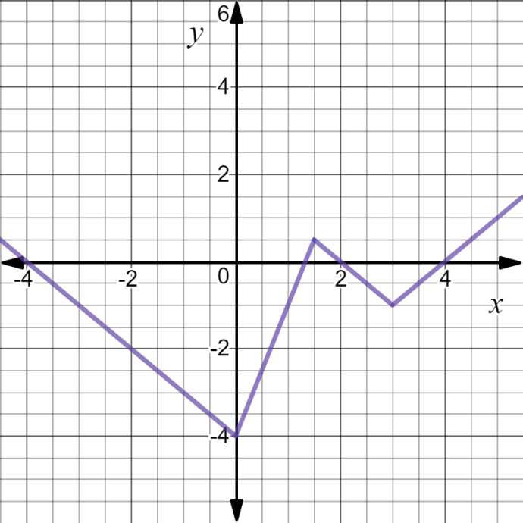
(a) (b)

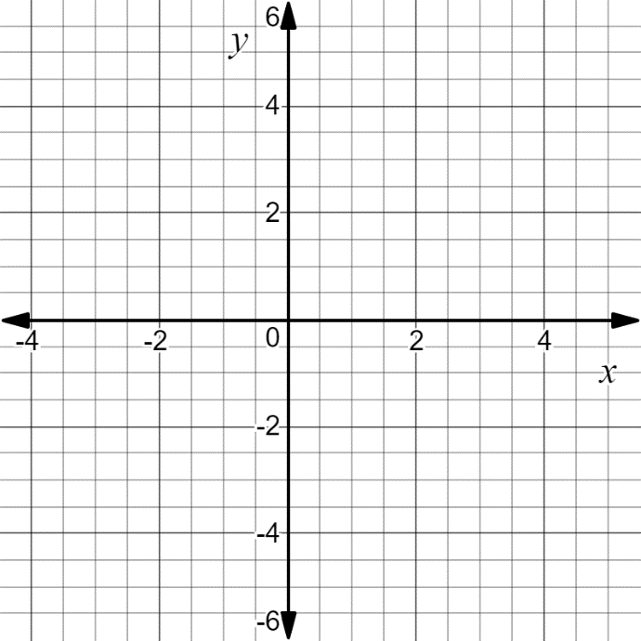

Question 8. (3 marks)

Find an expression for the inverse function of $q(x)$ where $q\left(x\right)=5-$ $\frac{1}{2x-3}$ and state its
domain and range.

Question 9. (4 marks)

Consider the graph of $y=$ $\frac{4x^{2}+4x}{x^{3}+x^{2}-4x-4}$

- Locate any asymptotes. (2)

- Describe any other discontinuities. (2)

Question 10. (6 marks)

Determine all of the asymptotes for each of the following functions:

- F(x) = $\frac{x^{2}+2x}{x-1}$ (2)

- G(x) = $\frac{x^{2}-4}{x(x+2)}$ (2)

- H(x) = $\frac{{2x}^{2}+1}{(x-1)(x+2)}$ (2)

Question 11. (5 marks)
The graph of $y=h(x)$ is shown below. It has asymptotes at $x=0, x=4, y=$ $\frac{2}{5}$ . On the next set of axes draw the graph of $y=$ $\frac{1}{h(x)}$ , clearly showing any roots and asymptotes.

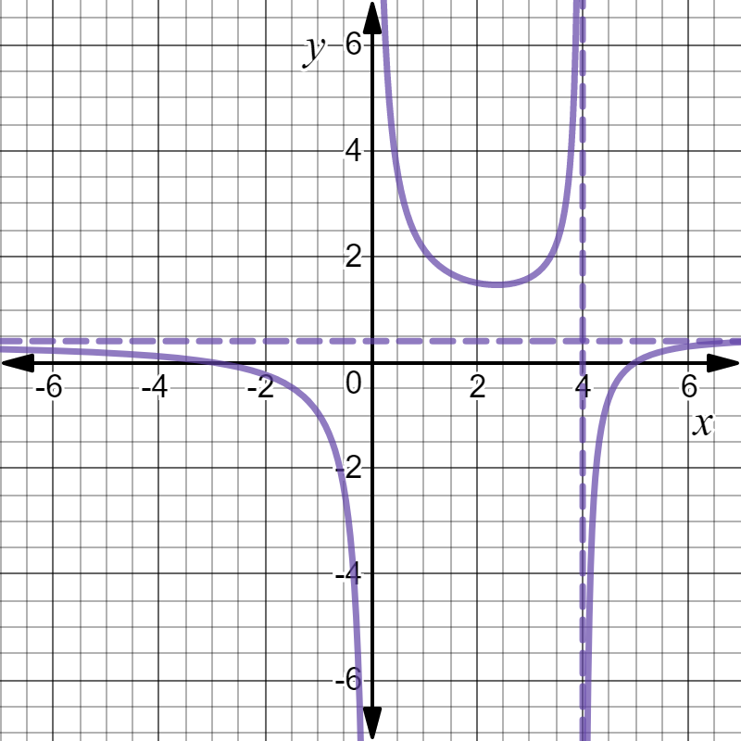

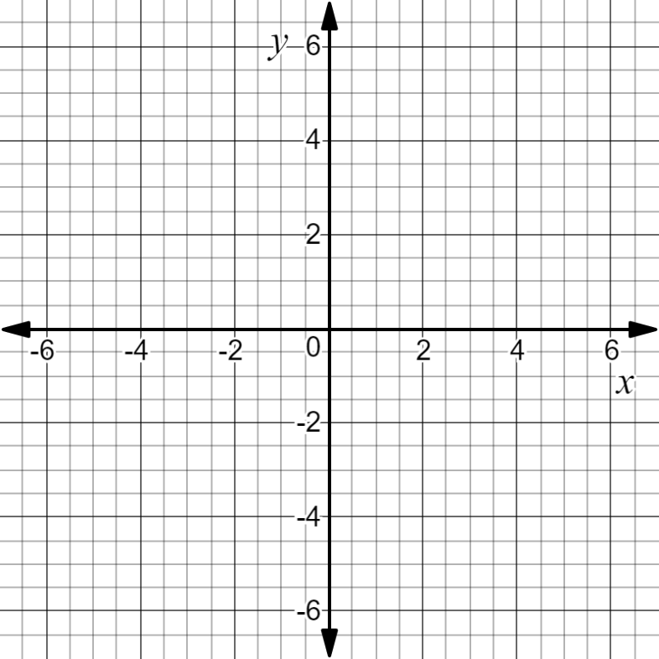

Question 12. (7 marks)

The graph of $g\left(x\right)=$ $\frac{(x-6)(x+1)}{x-3}$ , $x<3$ has asymptotes $x=3 and y=x-2$ as is shown below:
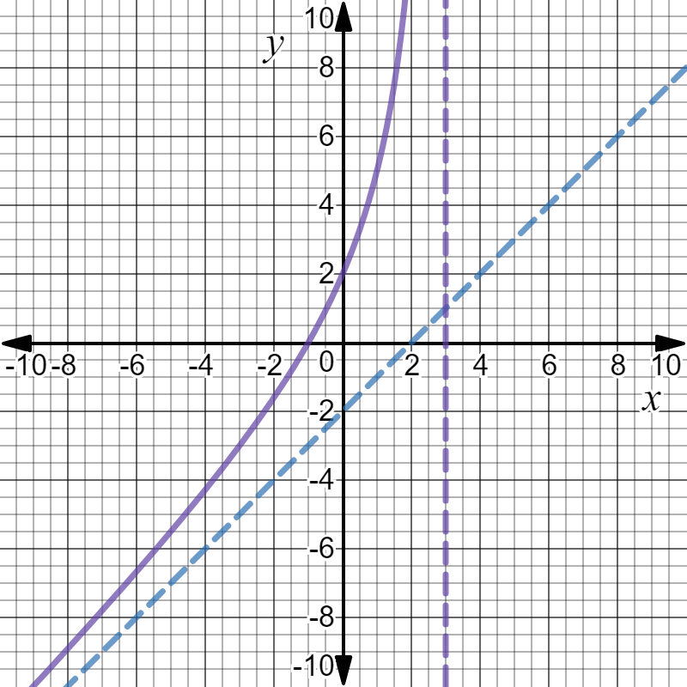

- Explain why $g$ has an inverse function $g^{-1}$ and find $g^{-1}(0)$ . (2)

- Sketch the graph of $y=g^{-1}(x)$ on the same set of axes above. Include any
asymptotes in your sketch. (3)

- Solve for $x ,$ $g^{-1}\left(x\right)=1.5$. (2)

Question 13. (4 marks)
Given that $p\left(x\right)=x^{2}-1$ and $q\left(x\right)=$ $\frac{3}{x}$ state the natural domain and the corresponding
range of each of the following functions:

- $poq(x)$ (2)

- $qop(x)$ (2)

End of Test Paper
This page has intentionally been left blank.

You may use this space to extend your working on a particular question or questions. Remember to number each extension.

